

DESIGN AND FABRICATION OF A PARABOLIC
SOLAR WATER HEATER USING COPPER PIPE

A Project Report
Submitted by
AMBIKA B | 611223114003
ARAVINTH R | 611223114006
BHUVANAN M | 611223114013
DHARANESHWARAN B | 611223114020

In partial fulfillment for the award of the degree
of
BACHELOR OF ENGINEERING
in
MECHANICAL ENGINEERING
KNOWLEDGE INSTITUTE OF TECHNOLOGY, SALEM
(An Autonomous Institution)

ANNA UNIVERSITY :: CHENNAI 600 025

JAN 2026

BONAFIDE CERTIFICATE

Certified that this project report “DESIGN AND FABRICATION OF A PARABOLICSOLAR WATER HEATER USING COPPER PIPE” is the Bonafide work of “AMBIKA B, ARAVINTH R, BHUVANAN M, and DHARANESHWARAN B” who carried out the project work under my supervision.

SIGNATURE
Dr. K.S. PRABHAKARAN, M.E., Ph.D.
HEAD OF THE DEPARTMENT
Associate Professor
Department of Mechanical Engineering
Knowledge Institute of Technology
Salem – 637 504.

SIGNATURE
Mr. A. KAMALAKKANNAN,M.E., (Ph.D).

SUPERVISOR
Assistant Professor
Department of Mechanical Engineering
Knowledge Institute of Technology
Salem – 637 504.

ACKNOWLEDGEMENT

We thank our beloved Executive Chairman and President Dr.PSS.SRINIVASAN, B.E., M.Tech., Ph.D., and all the members of Knowledge Institute of Technology Trust at this high time for providing us with excess of facilities to complete the project successfully.
My heartfelt gratitude to Dr. K. VISAGAVEL, M.E., Ph.D., FIE, Principal of KIOT, for his invaluable guidance and encouragement throughout the journey.
I am very much obliged to Dr. K.S. PRABHAKARAN, M.E., Ph.D., Head of the Department, Mechanical Engineering, for his valuable insights that significantly enhanced the quality of my project.
I am humbled and thankful Mr. S. SHANMUGAM, M.E., Professor of Practice, Department of Mechanical Engineering for Initiating the Institute To Industry (I2I) Course and Providing Valuable Industry Exposure . His guidance and motivation greatly enhanced our learning and contributed to the Successful completion of the project.
A sincere thanks to my Project Work Supervisor, Mr. A. KAMALAKKANNAN, M.E., (Ph.D)., Department of Mechanical Engineering, Department of Mechanical Engineering, for his exceptional guidance and unwavering support throughout the project's duration.
I also wish to acknowledge the entire teaching faculty, supporting staffs of the Mechanical Engineering Department, and my fellow students for their assistance and cooperation, which played a vital role in bringing the project to fruition.
I am forever thankful to all who contributed for the successful completion of the project.

ABSTRACT
The increasing demand for hot water in domestic and small-scale applications has resulted in greater dependence on conventional electrical and fuel-based water heating systems. These systems consume significant amounts of electricity or fossil fuels and contribute to operating costs and environmental pollution. Solar energy provides a clean and renewable alternative for water heating, particularly in regions receiving adequate solar radiation. This project focuses on the design and fabrication of a mechanically operated parabolic solar water heater that utilizes concentrated solar radiation to heat water. The proposed system consists of a parabolic reflector, wooden supporting structure, metal sheet, reflective sheet and copper pipe. The parabolic reflector is designed to concentrate incident solar radiation toward a common focal region. A copper pipe carrying water is positioned at the focal region so that the concentrated solar radiation directly heats the pipe. The parabolic reflector is constructed using a wooden support arrangement and a curved metal sheet. A reflective sheet is provided over the metal surface to improve the reflection of solar radiation. Based on the designed parabolic profile, the focal position is approximately 73 mm above the vertex of the parabola. The copper pipe is positioned at this focal location to receive maximum concentrated solar radiation. When sunlight falls on the reflective surface, the approximately parallel solar rays are reflected toward the focal region. The concentrated radiation increases the temperature of the copper pipe, and heat is transferred from the copper pipe to the water flowing through it. The complete system operates without sensors, electronic controllers, electrical heaters or motors. The prototype is intended to demonstrate the practical application of solar concentration, heat transfer and mechanical design principles for water heating. Experimental testing was performed by measuring the inlet and outlet water temperatures at different operating periods and solar conditions. The proposed system offers a simple, renewable and potentially low-operating-cost solution for solar water heating.
Keywords: Solar Water Heater, Parabolic Reflector, Solar Concentration, Copper Pipe, Focal Point, Solar Thermal Energy, Heat Transfer, Renewable Energy.

TABLE OF CONTENT

CHAPTER NO. | TITLE | PAGE NO.
 | ABSTRACT | iv
 | LIST OF TABLES | vi
 | LIST OF FIGURES | vii
 | LIST OF SYMBOLS | viii
 | LIST OF ABBREVIATIONS | ix
 | NOMENCLATURE | x
1 | INTRODUCTION | 1
1.1 | Problem Statement | 2
1.2 | Objectives
1.3 | Scope of the Project
1.4 | Need for the Proposed System | 3
1.5 | Project Methodology
2 | LITERATURE REVIEW | 5
3 | COMPONENTS SPECIFICATION AND DESCRIPTION | 8
3.1 | Components | 8
3.2 | Parabolic Reflector
3.3 | Wooden Supporting Structure | 9
3.4 | Metal Sheet | 10
3.5 | Reflective Sheet | 11
3.6 | Copper Pipe | 12
3.7 | Water Storage Tank | 13
3.8 | Water Tap | 14
4 | SYSTEM DESIGN AND WORKING PRINCIPLE | 16
4.1 | Overall System Architecture | 16
4.2 | Parabolic Geometry
4.3 | Focal Point Determination
4.4 | Reflector Design | 17
4.5 | Copper Pipe Positioning
4.6 | Heat Transfer Mechanism
4.7 | Water Flow Arrangement
4.8 | Working Principle
4.9 | System Flowchart | 18
4.10 | Design Consideration and Alternatives | 19
5 | DESIGN CALCULATIONS | 20
5.1 | Parabolic Equation | 20
5.2 | Focal Length
5.3 | Reflector Geometry
5.4 | Copper Pipe Heat Transfer | 21
5.5 | Useful Heat Gain
5.6 | Thermal Efficiency
5.7 | Heat Loss Estimation
5.8 | Worked Numerical Example | 22
5.9 | Sensitivity of Performance to Focal Alignment | 23
6 | PROTOTYPE DEVELOPMENT | 24
6.1 | Concept Development | 24
6.2 | CAD Design
6.3 | Wooden Frame Fabrication | 26
6.4 | Metal Sheet Preparation
6.5 | Reflective Sheet Installation
6.6 | Copper Pipe Installation | 27
6.7 | Final Assembly
6.8 | Quality Checks During Fabrication
7 | COST ESTIMATION | 29
7.1 | Material Cost | 29
7.2 | Fabrication Cost
7.3 | Total Project Cost | 30
8 | TESTING, RESULTS AND DISCUSSION | 31
8.1 | Experimental Setup | 31
8.2 | Inlet and Outlet Temperature Test
8.3 | Temperature Rise Test | 32
8.4 | Solar Radiation / Weather Observation | 33
8.5 | Water Flow Test
8.6 | Thermal Performance | 34
8.7 | Overall Performance
8.8 | Comparison With a Conventional Flat-Plate Collector | 35
9 | SAFETY, MAINTENANCE, ADVANTAGES AND APPLICATIONS | 37
9.1 | Safety Features | 37
9.2 | Maintenance Procedure
9.3 | Advantages
9.4 | Limitations | 38
9.5 | Applications
9.6 | Environmental And Economic Considerations | 39
10 | APPENDICES | 40
 | Appendix-1 Parabolic Profile | 40
 | Appendix-2 Components Specification
 | Appendix-3 Prototype Photographs | 42
11 | CONCLUSION | 45
12 | REFERENCES | 46

LIST OF TABLES

TABLE NO. | TITLE | PAGE NO.
3.1 | Components Used in the Prototype | 8
3.2 | Parabolic Reflector Specification | 9
3.3 | Wooden Frame Specification
3.4 | Copper Pipe Specification | 15
4.1 | Comparison of Concentrator Design Alternatives | 19
5.1 | Design Parameters | 20
5.2 | Comparative Focal Length Values
5.3 | Worked Example Summary | 22
5.4 | Qualitative Sensitivity of Performance to Focal Alignment Error | 23
6.1 | Fabrication Quality Checks | 27
7.1 | Material Cost | 29
7.2 | Fabrication Cost
7.3 | Total Project Cost | 30
8.1 | Experimental Temperature Readings | 32
8.2 | Water Temperature Rise
8.3 | Weather Observing Log | 33
8.4 | Thermal Performance | 34
8.5 | Repeated Trial Results | 35
8.6 | Qualitative Comparison with a Flat-Plate Collector | 36

LIST OF FIGURES
FIGURE NO. | TITLE | PAGE NO.
1.1 | Methodology of the Proposed Solar Water Heater | 4
3.4 | Metal Sheet | 10
3.5 | Reflective Sheet | 11
3.6 | Copper Pipe | 12
3.7 | Water Storage Tank | 13
3.8 | Water Tap | 14
4.1 | Overall System Architecture | 16
4.8 | System Flowchart | 18
6.2.1 | CAD Isometric View | 24
6.2.2 | CAD Front View | 25
6.2.3 | CAD Side View
6.2.4 | CAD Top View | 26
8.1 | Experimental Setup | 31
8.2 | Temperature Variation Graph | 33
8.3 | Temperature Rise Versus Time | 34
10.1 | Parabolic Profile Drawing | 40

LIST OF SYMBOLS, ABBREVLATIONS AND NOMENCLATURE

- SYMBOLS:
SYMBOL | DESCRIPTION | UNIT
f | Focal length of the parabola | mm
x | Horizontal distance from the axis | mm
y | Vertical distance from the vertex | mm
Q | Useful heat gained by water | J
m | Mass of water | kg
cₚ | Specific heat capacity of water | J/kg·K
ΔT | Temperature rise (Tout − Tin) | °C
Tᵢₙ | Inlet water temperature | °C
Tₒᵤₜ | Outlet water temperature | °C
ṁ | Mass flow rate of water | kg/s
Ṙᵤ | Useful thermal power | W
I | Solar irradiance | W/m²
A | Aperture area of the collector | m²
η | Thermal efficiency of the collector | %
Qₗ | Heat loss from the receiver | W
h | Convective heat transfer coefficient | W/m²·K

- ABBREVIATIONS

ABBREVIATION | FULL FORM
SWH | Solar Water Heater
PSC | Parabolic Solar Concentrator
IEA | International Energy Agency
IRENA | International Renewable Energy Agency
CAD | Computer Aided Design
cp | Specific heat capacity

NOMENCLATURE

TERM | DEFINITION
Solar Concentration | Focusing of incident solar radiation onto a smaller receiver area using a reflective surface.
Parabolic Reflector | A curved surface following a parabolic profile that reflects parallel incoming rays to a common focal point.
Focal Point | Point at which reflected solar radiation converges
Receiver | Component that absorbs concentrated solar radiation and transfers it to the working fluid.
Aperture Area | Effective area of the reflector that intercepts solar radiation
Thermal Efficiency | Ratio of useful heat gained by the water to total incident solar energy
Vertex | The lowest point of the parabolic curve

CHAPTER 1
INTRODUCTION
Solar energy is one of the most abundant renewable energy resources available on Earth. The energy received from the Sun can be directly converted into useful thermal energy for applications such as water heating, cooking, drying and industrial heating. Among these applications, solar water heating is one of the simplest and most practical methods of utilizing solar thermal energy. Unlike photovoltaic conversion, which requires semiconductor cells and electronic balance-of-system components, thermal utilization of solar radiation can be achieved through comparatively simple mechanical arrangements, making it attractive for low-cost, low-maintenance applications in both urban and rural settings.
Conventional water heating systems commonly depend on electricity, LPG or other fuels. Although these systems can provide rapid heating, their operation involves continuous energy consumption and operating cost. The increasing cost of energy and environmental concerns associated with conventional fuels create a need for simple renewable-energy-based heating systems. Electric geysers, in particular, place a significant load on the domestic electricity supply during peak morning and evening hours, which can strain local distribution infrastructure in regions with limited generation capacity.
A solar water heater uses solar radiation to increase the temperature of water. Conventional flat-plate solar collectors generally absorb solar radiation over a relatively large surface. A concentrating solar collector instead uses a reflective surface to direct solar radiation toward a smaller receiver area. This concentration can increase the temperature of the receiver and improve heat transfer to the working fluid. Concentrating collectors are therefore capable of achieving higher receiver temperatures than flat-plate collectors of comparable aperture area, since the same quantity of incident solar energy is redirected onto a much smaller absorbing surface.
The proposed project uses a parabolic reflector as the concentrating element. The geometry of a parabola allows approximately parallel incident solar rays to be reflected toward a common focal region. A copper pipe is placed at this focal region. Water flowing through the pipe receives thermal energy from the heated pipe. The choice of a parabolic trough rather than a point-focus paraboloid keeps the fabrication comparatively simple, since the reflector cross-section can be generated using two-dimensional wooden templates repeated along the length of the trough.
The proposed system is designed entirely using mechanical and thermal principles. There is no requirement for sensors, electronic controllers, IoT systems or electrical heating elements. This makes the system simple, potentially low-cost and suitable for demonstrating solar concentration and heat-transfer principles. The absence of electronic components also improves the reliability of the system in outdoor conditions, where dust, humidity and temperature variation can otherwise affect sensitive electronic circuitry.

1.1 PROBLEM STATEMENT
Conventional water heating systems depend mainly on electricity or fuel to produce hot water. Continuous use of electrical water heaters results in electricity consumption and increased operating cost. Fuel-based heating systems additionally consume non-renewable resources and may produce harmful emissions.
Although solar water heating provides a renewable alternative, many existing systems use comparatively complex collector arrangements, insulation systems, pumps, controllers or other supporting equipment. There is a need for a simple mechanical solar water heating system that can demonstrate concentrated solar heating using easily available materials.

1.2 OBJECTIVES
- To design a parabolic reflector for concentrating solar radiation.
- To determine the appropriate focal position of the parabolic reflector.
- To position a copper pipe at the focal region of the reflector.
- To fabricate a supporting structure using wooden members.
- To provide a metal sheet as the structural base for the reflective surface.
- To install a reflective sheet over the curved metal surface.
- To utilize concentrated solar radiation for heating a copper pipe.
- To transfer thermal energy from the copper pipe to flowing water.
- To fabricate a low-cost and simple mechanical prototype.
- To experimentally evaluate the temperature rise of water.
- To study the effect of solar exposure time on water temperature.
- To evaluate the practical feasibility of the proposed solar water heater.

1.3 SCOPE OF THE PROJECT
The scope of this project includes the design, fabrication and testing of a small-scale parabolic solar water heating prototype. The project covers parabolic reflector design, focal-point determination, selection of copper pipe, wooden support-frame design, metal-sheet fabrication, reflective-sheet installation, copper-pipe positioning, water inlet and outlet arrangement, solar concentration, heat transfer from the pipe to water, experimental measurement of water temperature, thermal performance evaluation and cost estimation.
The project is limited to a prototype-scale solar water heater and does not include electrical heating, electronic control, automatic sun tracking, sensors, pumps or IoT monitoring. Large-scale array integration, storage-tank design and integration with existing domestic plumbing systems are likewise treated as directions for future extension rather than part of the present prototype scope.

1.4 NEED FOR THE PROPOSED SYSTEM
- Renewable energy utilization – solar energy can be utilized directly for thermal applications.
- Reduction in electrical energy consumption – solar heating can reduce dependence on electrical water heaters during adequate sunlight.
- Simple mechanical construction – the system can be fabricated using relatively simple mechanical components.
- No electronic control requirement – basic heating operation does not require sensors, microcontrollers or electronic controllers.
- Low operating requirement – the primary energy input is sunlight rather than purchased electricity or fuel.
- Educational value – the prototype demonstrates solar energy, parabolic geometry, reflection, heat transfer, fluid flow, thermal engineering and mechanical fabrication.
Commercially available concentrating solar collectors, such as parabolic trough power-plant collectors, are engineered to a high degree of optical precision using metal or glass reflectors, motorized tracking mechanisms and specialized selective-coated receiver tubes. These systems, while highly efficient, are neither affordable nor necessary for small-scale domestic or educational water-heating needs. The proposed system therefore intentionally trades some optical precision and tracking accuracy for simplicity, affordability and ease of fabrication using materials that are readily available in a college workshop or a small fabrication unit.

1.5 PROJECT METHODOLOGY
The project begins with a study of solar thermal collectors and parabolic concentrating systems. The problem and objectives are then defined. A suitable parabolic geometry is developed based on the required focal distance. The reflector is fabricated using a wooden support structure and metal sheet. A reflective sheet is attached to the curved surface. The copper pipe is positioned at the calculated focal region. Water is allowed to flow through the pipe. The completed prototype is exposed to sunlight and tested under suitable outdoor conditions. Water temperature measurements are recorded at the inlet and outlet. The temperature rise and thermal performance are then evaluated.

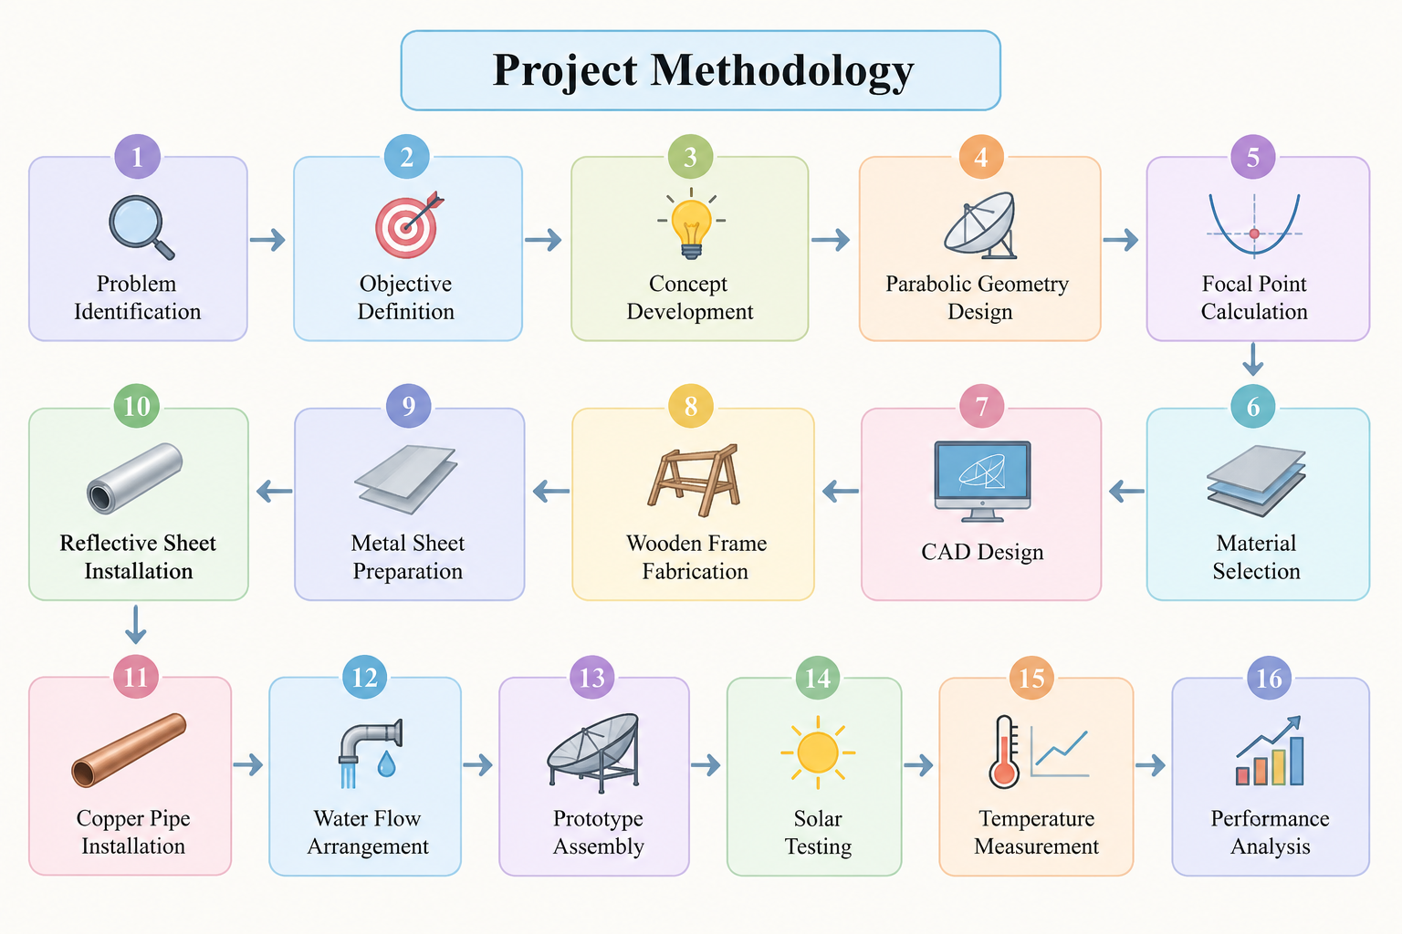
Figure 1.1 Methodology of the proposed solar water heater
Each stage of the methodology feeds directly into the next: the geometry determined during the design phase dictates the dimensions used in fabrication, and the fabrication tolerances achieved in the workshop, in turn, determine the accuracy of focal positioning that can be realized in the finished prototype and, ultimately, the thermal performance observed during outdoor testing.

CHAPTER 2
LITERATURE REVIEW

Solar Thermal Energy
Solar thermal technology converts solar radiation into useful heat. Solar thermal collectors are widely used for water heating and other low- and medium-temperature applications. The performance of a solar thermal system depends on solar radiation, collector geometry, absorber properties, heat transfer and environmental conditions. Researchers have generally classified solar thermal collectors into non-concentrating (flat-plate, evacuated tube) and concentrating (parabolic trough, parabolic dish, Fresnel, and heliostat field) categories, with concentrating collectors reserved for applications that demand higher receiver temperatures.

Solar Water Heating
Solar water heating systems absorb solar radiation and transfer the resulting thermal energy to water. The basic system consists of a solar collector, water-carrying passage and storage or delivery arrangement. The effectiveness of the system depends on the amount of solar radiation absorbed by the collector and the efficiency with which heat is transferred to water. Duffie and Beckman's classical treatment of solar engineering establishes the governing energy balance for a solar collector, in which the useful heat delivered to the fluid equals the absorbed solar radiation minus thermal losses to the surroundings, forming the theoretical basis used in the design calculations of Chapter 5 of this report.

Parabolic Solar Concentrators
A parabolic reflector is a concentrating solar collector in which the reflecting surface follows a parabolic geometry. When sunlight is incident approximately parallel to the axis of the parabola, the reflected rays converge toward the focal region. This principle allows a relatively large collector aperture to concentrate solar energy onto a comparatively small receiver. Rabl's treatment of active solar collectors describes how the concentration ratio, defined as the ratio of aperture area to receiver area, directly governs the achievable increase in receiver temperature for a given level of incident solar flux.

Copper as a Heat Transfer Material
Copper is commonly used in thermal applications because of its high thermal conductivity and good resistance to corrosion under suitable operating conditions. In the proposed system, the copper pipe functions as the receiver and water-carrying component. The concentrated solar radiation heats the outer surface of the pipe, and heat is conducted through the pipe wall before being transferred to the water. Compared with alternative receiver materials such as mild steel or aluminum, copper's high conductivity minimizes the temperature drop across the pipe wall, allowing more of the absorbed solar energy to reach the flowing water rather than being retained in the pipe material.

Reflective Surfaces
The efficiency of a concentrating collector depends strongly on the reflectivity and surface quality of its reflective material. A suitable reflective sheet helps redirect a greater fraction of the incident solar radiation toward the focal region. Kalogirou's review of solar thermal collectors and applications notes that specular reflectance of the concentrator surface, together with the accuracy of the parabolic profile, are the two most influential optical parameters affecting the overall performance of a concentrating collector.

Fabrication of Low-Cost Parabolic Trough Collectors
Several studies have reported the fabrication of parabolic trough collectors from inexpensive materials such as plywood, galvanized sheet and mirror-finish or reflective aluminum foil. These studies generally conclude that a moderate concentration ratio, in the range of 5 to 15, is sufficient to achieve a useful temperature rise in the working fluid for domestic hot-water applications, without requiring the higher optical precision associated with power-generation-scale collectors.

Focal-Length Accuracy and Receiver Positioning
Research on concentrating collectors consistently highlights those small deviations in the position of the receiver relative to the calculated focal line can significantly reduce the fraction of reflected radiation intercepted by the receiver. This finding directly informed the emphasis placed, in the present project, on accurate calculation of the focal distance and on providing adjustable pipe supports during fabrication.
Comparison of Absorber Coatings
Comparative studies of absorber surface treatments have shown that a matte-black or selective coating on the receiver pipe can improve the fraction of incident concentrated radiation absorbed, as opposed to bare or reflective metal surfaces, which reflect a larger proportion of incoming radiation without absorbing it. This finding is referenced in the present study when discussing possible surface-treatment improvements for the copper pipe receive
Effect of Wind and Ambient Conditions
Field studies of outdoor concentrating collectors report those convective losses from the receiver surface increase substantially in windy conditions, reducing the net useful heat gain even when solar irradiance remains constant. This observation is consistent with the heat-loss considerations discussed in Chapter 5 of the present report.

Manual versus Automatic Sun-Tracking
Comparative studies of tracking strategies for small-scale parabolic collectors indicate that a fixed or manually-adjusted reflector, if realigned toward the Sun every 30 to 60 minutes, can achieve a large fraction of the thermal performance of a fully automatic tracking system, at a much lower cost and complexity. This supports the manual-alignment approach adopted for the prototype described in this report.

Feasibility of Small-Scale Concentrating Collectors
Techno-economic assessments of small parabolic solar water heaters generally report a payback period considerably shorter than that of flat-plate collectors of comparable thermal output, owing to the lower material cost associated with a wooden-and-sheet-metal reflector compared with a glazed flat-plate absorber panel.

Structural Considerations for Wind Loading
Outdoor structural studies of lightweight trough-type reflectors note that wind loading on the large, curved reflector surface can introduce vibration and, over time, gradual distortion of the parabolic profile if the supporting frame is not adequately braced. This consideration influenced the choice of a wooden frame with cross-bracing members in the present design, rather than a thin unsupported sheet-metal shell.

Water Quality and Pipe Scaling Effects
Long-term operational studies of copper-pipe solar receivers report that hard or mineral-rich water can gradually deposit scale on the internal pipe surface, increasing the thermal resistance between the pipe wall and the flowing water and reducing the useful heat gain over repeated cycles of use. Periodic flushing of the pipe is recommended in such studies as a simple maintenance measure, which is reflected in the maintenance procedure described in Chapter 9 of this report.

Educational and Demonstration Use of Solar Concentrators
A separate body of literature addresses the use of simple parabolic solar concentrators as teaching aids in engineering and physics curricula. These studies report that hands-on fabrication of a working concentrator improves student understanding of reflection geometry, heat transfer and renewable-energy concepts more effectively than classroom instruction alone, supporting the educational motivation for the present project in addition to its practical water-heating function.

CHAPTER 3
COMPONENTS SPECIFICATION AND DESCRIPTION

3.1 COMPONENTS
The components used in the fabrication of the prototype are listed in Table 3.1. Each component is described in detail in the following sections.
S.No. | Component | Quantity
1 | Wooden supporting structure | As required
2 | Curved metal sheet | 1 set
3 | Reflective sheet | 1 set
4 | Copper pipe | 1
5 | Pipe support brackets | As required
6 | Water inlet connection | 1
7 | Water outlet connection | 1
8 | Fasteners | As required
9 | Adhesive / fixing material | As required
10 | Base / support arrangement | 1 set
Table 3.1 Components Used in the Prototype

3.2 PARABOLIC REFLECTOR
The parabolic reflector is the main component of the solar water heater. Its function is to collect solar radiation over its aperture and concentrate the reflected radiation toward the focal region. The reflector consists of a curved surface whose cross-section follows a parabolic profile.
Functions: collect solar radiation, reflect sunlight, concentrate solar radiation and direct concentrated energy toward the copper pipe.
Parameter | Value / Description
Profile | Parabolic (x² = 4fy)
Focal length (f) | 73 mm
Reflector base | Curved metal sheet on wooden frame
Function | Concentrates solar radiation onto receiver
Table 3.2 Parabolic Reflector Specification

3.3 WOODEN SUPPORTING STRUCTURE
Wood is used to provide the structural framework required to maintain the parabolic shape. The supporting members are positioned on the sides of the reflector. They determine and maintain the required curvature.
Functions include supporting the metal sheet, maintaining parabolic geometry, providing structural rigidity, supporting the reflective surface and providing mounting points for the copper pipe.
Parameter | Description
Material | Plywood / seasoned timber
Profile | Cut to parabolic template
Function | Maintains reflector curvature and rigidity
Joining method | Mechanical fasteners and adhesive
Table 3.3 Wooden Frame Specification

3.4 METAL SHEET


Figure 3.4 Metal Sheet
A metal sheet is positioned over/around the wooden supporting structure to form the base of the curved reflector. The metal sheet must be sufficiently rigid to maintain the designed profile. It provides the curved reflector base, supports the reflective sheet, maintains the parabolic profile and transfers structural loads to the wooden frame.

3.5 REFLECTIVE SHEET
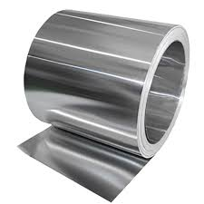

Figure 3.5 Reflective Sheet
The semi-cylindrical reflector is the main component responsible for concentrating solar radiation onto the absorber pipe. It is made using an aluminium foil sheet due to its high reflectivity, lightweight nature, and low cost. The curved shape of the reflector helps in focusing sunlight toward the focal line where the copper absorber pipe is positioned. This concentration of solar energy increases heat absorption and improves the thermal efficiency of the system.
The reflector is designed with proper radius and focal distance to ensure maximum sunlight concentration throughout the day. Compared to flat plate collectors, the semi-cylindrical reflector provides better heat concentration and faster water heating performance. The use of aluminium foil also reduces fabrication cost while maintaining effective solar reflection capability.
The reflector is mounted on the MS frame structure and connected with the tracking mechanism. The rotating arrangement allows the reflector to continuously align toward the sun for maximum solar energy absorption.
The reflective surface is polished properly to improve sunlight reflection and minimize energy loss. The semi-cylindrical design also provides uniform heat distribution along the absorber pipe for efficient water heating. Due to its simple construction and economical materials, the reflector is highly suitable for low-cost solar thermal applications.

3.6 COPPER PIPE
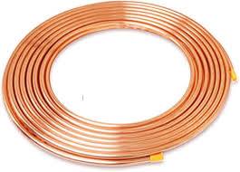

Figure 3.6 Copper Pipe
The copper absorber pipe is used to absorb concentrated solar heat energy from the reflector. It is positioned at the focal line of the semi-cylindrical reflector where maximum solar radiation is concentrated. Copper is selected because it has excellent thermal conductivity, corrosion resistance, and efficient heat transfer characteristics.
When sunlight is reflected onto the copper pipe, thermal energy is absorbed and transferred to the water flowing inside the pipe. This process increases the water temperature rapidly and improves the heating efficiency of the system. The pipe is designed to withstand high temperatures and continuous water flow conditions.
The absorber pipe plays a major role in determining the thermal performance of the solar water heater. Proper positioning of the pipe at the focal line ensures maximum heat absorption and efficient energy transfer.
The copper pipe is arranged in a coiled or straight configuration to increase the contact area between the water and the heated surface. The black coated surface of the pipe further improves solar heat absorption by reducing reflection losses. Due to its durability and long operational life, copper is widely used in solar thermal applications.
The absorber pipe is connected to the insulated storage tank through heat-resistant pipe connections for smooth water circulation. Efficient heat transfer from the copper pipe helps in achieving higher water temperatures within a shorter duration. The overall performance of the solar water heater mainly depends on the heat absorption capability and placement accuracy of the absorber pipe.

3.7 WATER STORAGE TANK ( INLET / OUTLET)
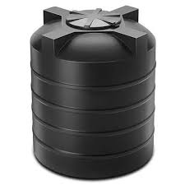

Figure 3.7 Water Storage Tank
The water storage tank is used to store the heated water produced by the solar heating system. It is insulated using materials such as rockwool or PU foam to minimize thermal losses and maintain water temperature for longer durations.
The heated water from the copper absorber pipe is transferred to the storage tank through insulated pipe connections. The tank is designed to withstand hot water temperatures and provide continuous hot water supply for domestic applications.
The insulation improves heat retention and increases the efficiency of the overall system. Proper insulation also reduces energy loss during cloudy weather and nighttime conditions. The storage tank plays an important role in maintaining a steady supply of hot water even after solar heating is reduced.
The tank is fabricated using corrosion-resistant material to improve durability and operational life. It is designed with proper inlet and outlet connections for smooth water circulation and efficient storage. The insulated tank helps in maintaining water temperature for several hours without additional heating.
The capacity of the storage tank is selected based on domestic water requirements and heating performance. Efficient storage of thermal energy improves the overall effectiveness and reliability of the solar water heating system. The tank also supports continuous hot water availability for residential and small-scale industrial applications.

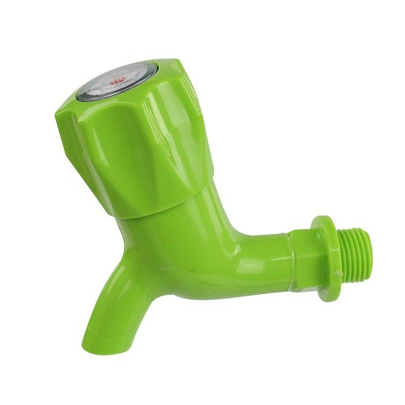
3.8 WATER TAP

3.8 Water Tap
The water tap is used to control the flow of water from the solar water heating system. It is connected at the outlet section of the storage tank or pipe line to regulate the discharge of heated water. The tap allows the user to easily open or close the water flow according to the requirement.
The tap is generally made of plastic or metal material with good corrosion resistance and durability. It is designed to withstand continuous water flow and moderate temperature conditions. Proper sealing arrangement inside the tap prevents water leakage and ensures smooth operation.
In the proposed system, the water tap helps in controlling both cold water inlet and hot water outlet connections. It provides convenient operation during water filling, draining, and maintenance activities. The compact design and simple installation make it suitable for domestic solar water heating applications.
The use of a quality water tap improves the reliability and safety of the system by maintaining proper water flow control. It also helps in reducing water wastage and supports efficient utilization of heated water generated by the solar collector system.

Parameter | Value / Description
Material | Copper
Position | At focal line, 73 mm above vertex
Thermal conductivity | High (≈ 385 W/m·K)
Function | Absorbs concentrated radiation, heats water
Table 3.4 Copper Pipe Specification

CHAPTER 4
SYSTEM DESIGN AND WORKING PRINCIPLE

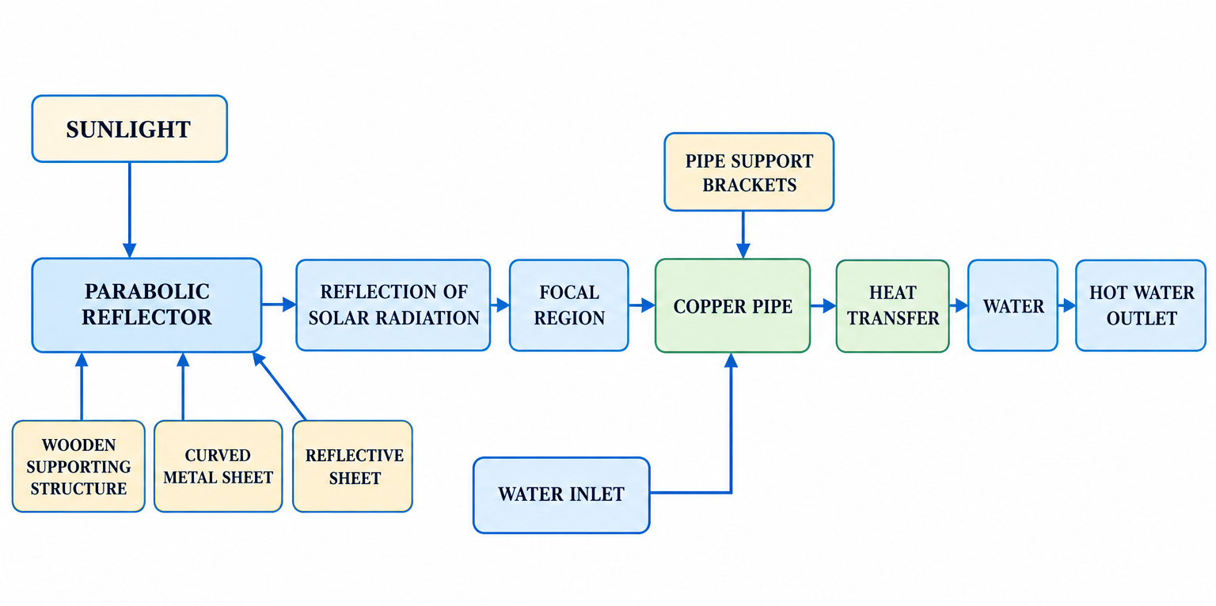
4.1 OVERALL SYSTEM ARCHITECTURE
Figure 4.1 Overall System Architecture

4.2 PARABOLIC GEOMETRY
The parabolic reflector is designed using the standard equation x² = 4fy, where x is horizontal distance from the axis, y is vertical distance from the vertex and f is focal length. For the present design, f = 73 mm. Therefore, x² = 4(73)y = 292y, or y = x²/292. This equation can be used to generate the parabolic profile.

4.3 FOCAL POINT DETERMINATION
The vertex is the lowest point of the parabolic curve. The focus is located on the axis of symmetry at a distance equal to the focal length from the vertex. For the current design: Vertex = (0,0), Focus = (0,73 mm). Therefore F = (0,73 mm). The copper pipe should be positioned close to this focal region.

4.4 REFLECTOR DESIGN
The reflector consists of wooden side supports, curved metal sheet, reflective sheet and copper pipe receiver. The wooden supports define the profile of the parabola. The metal sheet follows this profile and provides the structural base. The reflective sheet is placed on the inner surface. The reflective surface must be as smooth as practical because wrinkles or uneven surfaces can scatter the reflected rays and reduce concentration.

4.5 COPPER PIPE POSITIONING
The copper pipe is placed at the focal region of the reflector. The correct positioning is extremely important because the concentrated solar radiation must fall directly on the pipe. If the pipe is placed too far above or below the focal region, the reflected rays may not concentrate effectively on the pipe. Therefore, the pipe support should allow accurate positioning during assembly.

4.6 HEAT TRANSFER MECHANISM
The heat transfer takes place in three primary stages: Stage 1 – Solar radiation reaches the reflective surface. Stage 2 – The parabolic surface reflects the incoming solar rays toward the focal region. Stage 3 – The concentrated radiation heats the copper pipe. Heat is then transferred through the copper pipe wall to the water. The simplified heat-transfer path is: Sun → Reflective Sheet → Copper Pipe → Pipe Wall → Water.

4.7 WATER FLOW ARRANGEMENT
Cooler water enters the copper pipe through the inlet. As water travels through the pipe, it absorbs heat from the copper pipe. The heated water leaves through the outlet. Basic arrangement: Water Source → Inlet → Heated Copper Pipe → Outlet → Hot Water.

4.8 WORKING PRINCIPLE
The working principle of the proposed system is based on solar concentration and heat transfer. When the system is placed under sunlight, solar radiation falls on the parabolic reflective surface. Since the reflector follows a parabolic geometry, approximately parallel sunlight rays incident on the reflector are reflected toward the focal region. The copper pipe is positioned at this focal region. The concentrated solar radiation therefore falls onto the external surface of the copper pipe and increases its temperature.
The copper pipe conducts the absorbed thermal energy through its wall. Water flowing through the pipe receives this thermal energy by convection. Consequently, the temperature of the water increases as it passes through the heated section. The heated water is then discharged through the outlet for further use. The complete process takes place without electrical heating or electronic control.

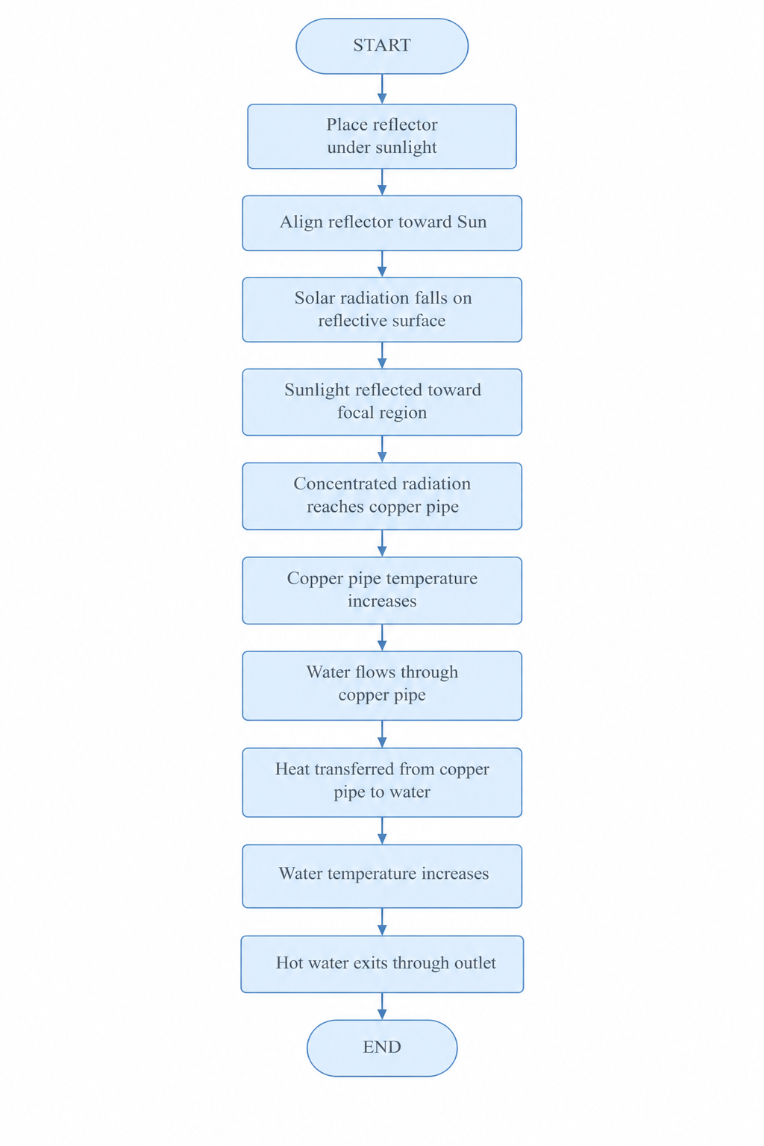
4.9 SYSTEM FLOWCHART
Figure 4.8 System Flowchart

4.10 DESIGN CONSIDERATIONS AND ALTERNATIVES
Before finalizing the trough-type parabolic reflector with a linear copper-pipe receiver, two alternative concentrator geometries were considered: a point-focus paraboloid dish with a compact coiled receiver, and a flat-plate collector fitted with planar reflective booster mirrors along its edges. Table 4.1 summarizes the comparative advantages and disadvantages of each option that were weighed during the concept-selection stage.
Design Option | Key Advantage | Key Drawback
Parabolic trough (adopted) | Simple 2-D profile; easy wooden templates; linear receiver pipe | Lower concentration ratio than a point-focus dish
Point-focus paraboloid dish | High concentration ratio; small receiver | Complex 3-D fabrication; small, hard-to-align focal spot
Flat-plate with booster mirrors | Very simple construction | Limited additional concentration; large absorber area required
Table 4.1 Comparison of Concentrator Design Alternatives
The trough geometry was ultimately selected because it offers a practical balance between fabrication simplicity, using only two-dimensional wooden templates repeated along the trough length, and a useful concentration ratio, while allowing the receiver to be a straightforward length of copper pipe rather than a specially coiled or shaped absorber.

CHAPTER 5

DESIGN CALCULATIONS

5.1 PARABOLIC EQUATION
General equation: x² = 4fy. Given f = 73 mm. Therefore, x² = 292y, and y = x²/292. This equation defines the parabolic profile used to generate the wooden side-support templates.

5.2 FOCAL LENGTH
From the current design, f = 73 mm. Therefore, the focal distance is 73 mm. The copper pipe receiver is positioned around this focal location.
Parameter | Symbol | Value
Focal length | f | 73 mm
Vertex | (0, 0) | —
Focus | (0, f) | (0, 73 mm)
Table 5.1 Design Parameters

5.3 REFLECTOR GEOMETRY
The final reflector dimensions must be obtained from the completed CAD model. The aperture width, length and depth should be recorded in the final report and used to calculate the actual collector area. As an illustrative comparison, Table 5.2 shows how the resulting focal distance changes for a fixed aperture half-width if a shallower or deeper parabolic profile is chosen, which is useful when selecting a practical profile depth for fabrication.
Aperture Half-Width, x (mm) | Focal Length, f (mm) | Depth, y (mm)
100 | 73 | 34.2
150 | 73 | 77.1
200 | 73 | 137.0
Table 5.2 Comparative Focal Length / Depth Values
A shallower profile (smaller depth-to-aperture ratio) is generally easier to fabricate accurately using hand tools, whereas a deeper profile provides a shorter focal length and, consequently, a more compact receiver arrangement. The design value of f = 73 mm represents a practical compromise between ease of fabrication and a workable focal distance for pipe mounting.

5.4 COPPER PIPE HEAT TRANSFER
Heat transfer from the heated pipe to the water depends on pipe material, pipe dimensions, water flow rate, temperature difference and exposure conditions. The experimentally measured inlet and outlet temperatures should be used for performance calculations. The overall thermal resistance between the concentrated solar radiation striking the pipe's outer surface and the flowing water may be represented as a series combination of the conduction resistance through the copper pipe wall and the convective resistance between the inner pipe surface and the water.
For a thin-walled copper pipe, the conduction resistance is small compared with the convective resistance because of copper's high thermal conductivity (approximately 385 W/m·K). Consequently, the rate of heat transfer to the water is governed primarily by the convective heat transfer coefficient inside the pipe, which in turn depends on the water flow rate and flow regime (laminar or turbulent).

5.5 USEFUL HEAT GAIN
The useful heat gained by water is Q = m cp ΔT, where Q is useful heat gained in joules, m is mass of water in kg, cp is specific heat capacity of water (approximately 4186 J/kg·K), and ΔT is temperature rise. ΔT = Tout − Tin. Therefore Q = m cp (Tout − Tin).

5.6 THERMAL EFFICIENCY
For continuous flow, useful thermal power is Qdot = mdot cp (Tout − Tin). Approximate collector thermal efficiency is η = Qu/(IA), or η = [mdot cp (Tout − Tin)]/(IA), where I is solar irradiance and A is aperture area. Use this calculation only when reliable irradiance and dimensional data are available.

5.7 HEAT LOSS ESTIMATION
In addition to the useful heat delivered to the water, a portion of the concentrated solar radiation absorbed by the copper pipe is lost to the surroundings through convection and radiation from the exposed pipe surface. The convective heat loss from the receiver may be approximated as Qₗ = h Aₛ (Tp − Ta), where h is the convective heat transfer coefficient at the pipe's outer surface, Aₛ is the exposed surface area of the pipe, Tp is the average pipe surface temperature and Ta is the ambient air temperature.
Radiative losses become significant only at higher receiver temperatures and are generally small for the modest temperature rise expected in this prototype-scale system. Nevertheless, minimizing exposed pipe length outside the concentrated-radiation zone, and shielding the pipe from wind where practical, can help reduce these losses and improve the net useful heat delivered to the water.

5.8 WORKED NUMERICAL EXAMPLE
As an illustrative calculation, consider a trial in which 1.5 litres (1.5 kg) of water is collected over a 30-minute exposure period, with an inlet temperature of 30°C and an outlet temperature of 45°C.
ΔT = 45 − 30 = 15°C
Q = m cp ΔT = 1.5 × 4186 × 15 = 94,185 J ≈ 94.2 kJ
If this heat is delivered over 30 minutes (1800 seconds), the average useful thermal power is:
Qdot = Q / t = 94,185 / 1800 ≈ 52.3 W
If the measured solar irradiance during the trial is, for example, I = 700 W/m² and the reflector aperture area is A = 0.5 m², the approximate thermal efficiency is:
η = Qdot / (I A) = 52.3 / (700 × 0.5) = 52.3 / 350 ≈ 0.149, or approximately 14.9%

Quantity | Symbol | Value
Mass of water | m | 1.5 kg
Temperature rise | ΔT | 15 °C
Useful heat gain | Q | 94.2 kJ
Exposure time | t | 1800 s
Useful thermal power | Qdot | 52.3 W
Approx. efficiency | η | ≈ 14.9%
Table 5.3 Worked Example Summary
This example is provided only to illustrate the calculation procedure; actual efficiency figures depend strongly on the measured irradiance, ambient temperature, wind conditions, flow rate and the accuracy of focal alignment achieved during the specific test, and must be recalculated using the experimental data recorded for the fabricated prototype (see Chapter 8).

5.9 SENSITIVITY OF PERFORMANCE TO FOCAL ALIGNMENT
Because the useful heat gain depends directly on the fraction of reflected solar radiation that actually strikes the copper pipe, small errors in focal-point positioning can have a disproportionately large effect on measured performance. If the pipe is displaced from the true focal line by a distance comparable to the pipe's own diameter, a significant portion of the reflected rays may pass above or below the receiver without being intercepted at all.
For this reason, the pipe-support brackets described in Section 3.7 were designed to allow fine adjustment of pipe height and lateral position after initial assembly, so that the receiver position could be verified and corrected, for example by observing the location of the brightest concentrated spot on a temporary white card held at the expected focal line, before final fixing.
Table 5.4 illustrates, in qualitative terms, how sensitive the collector's performance is expected to be to positioning error, based on the general relationship between concentration geometry and interception fraction discussed in the literature reviewed in Chapter 2.
Focal Alignment Error | Expected Effect on Performance
Within ± 2 mm of true focus | Minimal loss; most reflected rays intercepted
± 5–10 mm from true focus | Noticeable reduction in ΔT; partial ray interception
> 15 mm from true focus | Significant performance loss; receiver largely misses focal band
Table 5.4 Qualitative Sensitivity Of Performance to Focal Alignment Error

CHAPTER 6

PROTOTYPE DEVELOPMENT

6.1 CONCEPT DEVELOPMENT
The initial concept was developed based on the requirement to heat water using solar energy without electrical or electronic components. A parabolic reflector was selected because its geometry allows sunlight to be concentrated toward a focal region. A copper pipe was selected as the receiver because it can simultaneously carry water and transfer heat. Alternative concepts, such as a flat-plate absorber with a reflective booster mirror, were considered during the concept stage but were set aside in favor of the parabolic trough approach because of its higher achievable concentration ratio for a given aperture size.

6.2 CAD DESIGN
The CAD model should include the overall reflector, parabolic profile, wooden supports, metal sheet, reflective surface, copper pipe, pipe support, water inlet, water outlet and base/support structure. Recommended CAD views are isometric, front, side, top and sectional views, together with a parabolic profile showing the focal dimension.
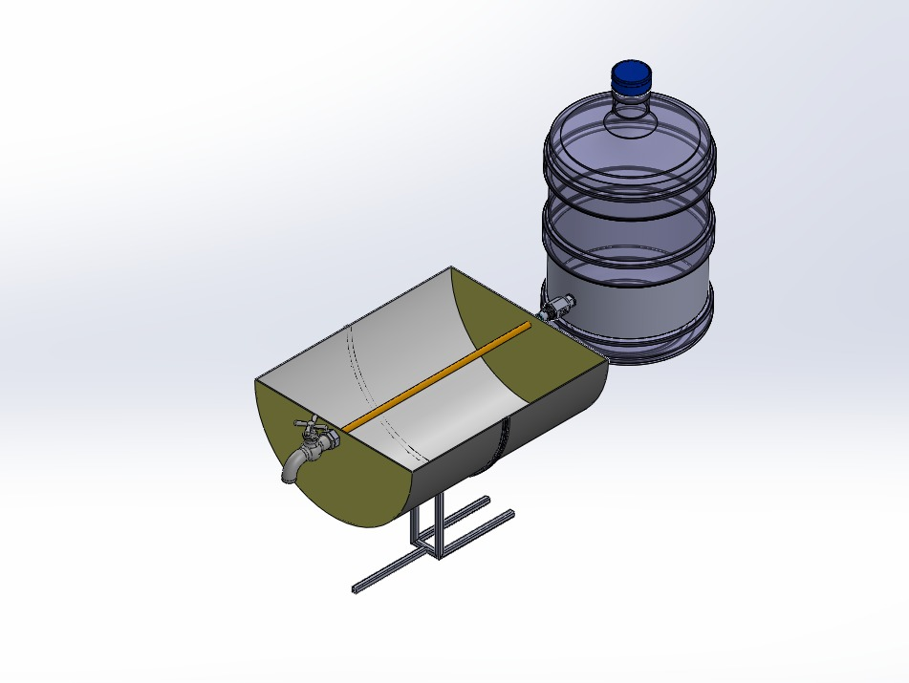
6.2.1 Isometric View

Figure 6.2.1 CAD Isometric View
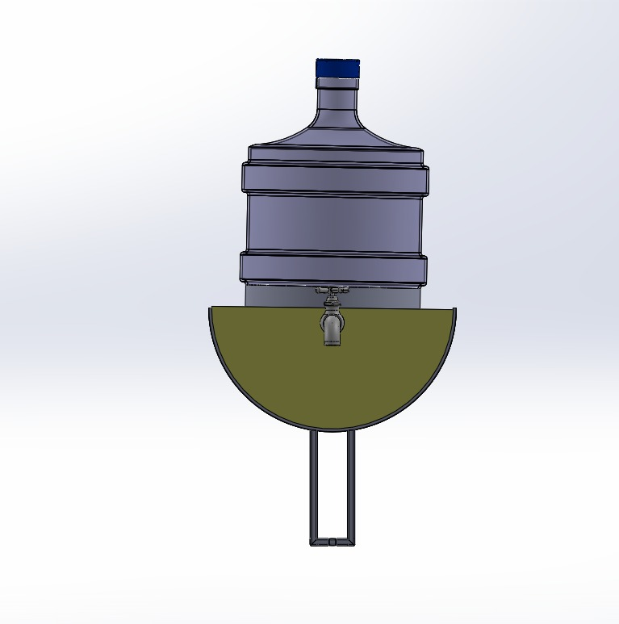
6.2.2 Front View

Figure 6.2.2 CAD Front View
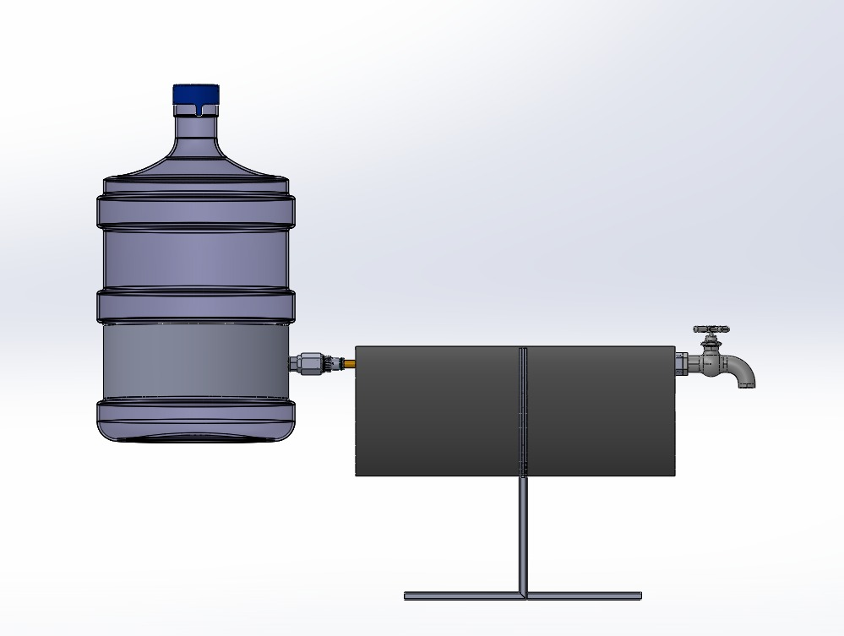
6.2.3 Side View

Figure 6.2.3 CAD Side View

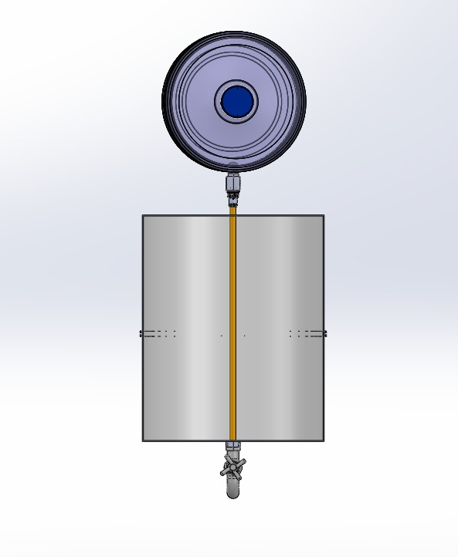
6.2.4 Top View
Figure 6.4 CAD Top View

6.3 WOODEN FRAME FABRICATION
The wooden members are cut according to the dimensions obtained from the design. The side supports are shaped or positioned according to the parabolic profile. The supports are joined using suitable mechanical fasteners or adhesive. The completed wooden frame is checked for dimensional accuracy, symmetry, rigidity and correct parabolic profile.

6.4 METAL SHEET PREPARATION
The metal sheet is cut according to the required collector dimensions. It is then formed or mounted onto the wooden structure to follow the required parabolic profile. The surface is checked for excessive deformation.

6.5 REFLECTIVE SHEET INSTALLATION
The reflective sheet is fixed over the metal surface. The sheet should be smooth, properly tensioned, free from major wrinkles, firmly attached and properly aligned with the parabolic surface.

6.6 COPPER PIPE INSTALLATION
The copper pipe is installed above the reflective surface at the focal region. The pipe supports are positioned so that the pipe remains approximately at the designed focal distance. The inlet and outlet connections are then attached. All joints are checked for leakage.

6.7 FINAL ASSEMBLY
The final assembly consists of wooden frame → metal parabolic surface → reflective sheet → copper pipe receiver → water inlet/outlet. The final prototype is then positioned outdoors for testing.
During assembly, particular attention was paid to ensuring that the copper pipe ran parallel to the trough axis along its full length, since any twist or bow in the pipe would cause part of its length to fall outside the concentrated-radiation band, reducing the effective heating length and, consequently, the overall temperature rise achieved for a given flow rate.

6.8 QUALITY CHECKS DURING FABRICATION
A set of basic quality checks was carried out at each fabrication stage to minimize the accumulation of small errors that could otherwise degrade the final optical and thermal performance of the prototype.
Fabrication Stage | Quality Check Performed
Wooden frame | Verify parabolic profile against template; check symmetry of both side supports
Metal sheet forming | Check for flat spots, kinks or excessive local curvature deviation
Reflective sheet installation | Inspect for wrinkles, air bubbles and uniform adhesion
Copper pipe positioning | Verify height and lateral position against calculated focal line
Water connections | Pressure-check joints for leakage before outdoor testing
Overall assembly | Confirm structural rigidity and stability on the support base
Table 6.1 Fabrication Quality Checks
These checks were repeated after any adjustment made during testing, since realigning the reflector or repositioning the pipe support could inadvertently introduce a new source of misalignment if not verified afterward.

CHAPTER 7

COST ESTIMATION

7.1 MATERIAL COST
S.NO. | MATERIAL | QUANTITY | UNIT COST (₹) | TOTAL (₹)
1 | Wooden members | 4 Nos. | 100 | 400
2 | Metal sheet | 1 No. | 500 | 500
3 | Reflective sheet | 2 m² | 200 | 400
4 | Copper pipe | 2 m | 500 | 1,000
5 | Pipe supports | 4 Nos. | 50 | 200
6 | Water fittings | 1 Set | 200 | 200
7 | Fasteners | 1 Set | 150 | 150
8 | Adhesive / fixing material | 1 Set | 150 | 150
 | TOTAL |  |  | ₹3,000
Table 7.1 Material Cost

7.2 FABRICATION COST
S.NO. | FABRICATION ACTIVITY | COST (₹)
1 | Wooden frame preparation | 400
2 | Metal sheet cutting/forming | 500
3 | Reflective sheet installation | 300
4 | Pipe bending/cutting | 200
5 | Assembly | 300
6 | Miscellaneous | 100
Table 7.2 Fabrication Cost

7.3 TOTAL PROJECT COST
Total Cost = Material Cost + Fabrication Cost.
Category | Cost
Material Sub-total | ₹ 3000
Fabrication Sub-total | ₹ 1800
Total Project Cost | ₹4800
Table 7.3 Total Project Cost
The parabolic reflector approach described in this report uses materials — wood, sheet metal, reflective film and a length of copper pipe — that are generally lower in cost than the glazed absorber panels, insulated backing and header manifolds required for a flat-plate collector of comparable aperture area. Actual figures should nonetheless be confirmed against local market prices at the time of procurement.

CHAPTER 8
RESULTS AND DISCUSSION

8.1 EXPERIMENTAL SETUP
The Fabricated Solar Water Heater Is Positioned Outdoors in An Open Area with Direct Exposure to Sunlight. The Reflector Is Oriented Toward the Sun So That Solar Radiation Falls onto The Reflective Surface. Water Is Supplied to The Copper Pipe Through the Inlet. The Outlet Water Is Collected After Passing Through the Heated Pipe.
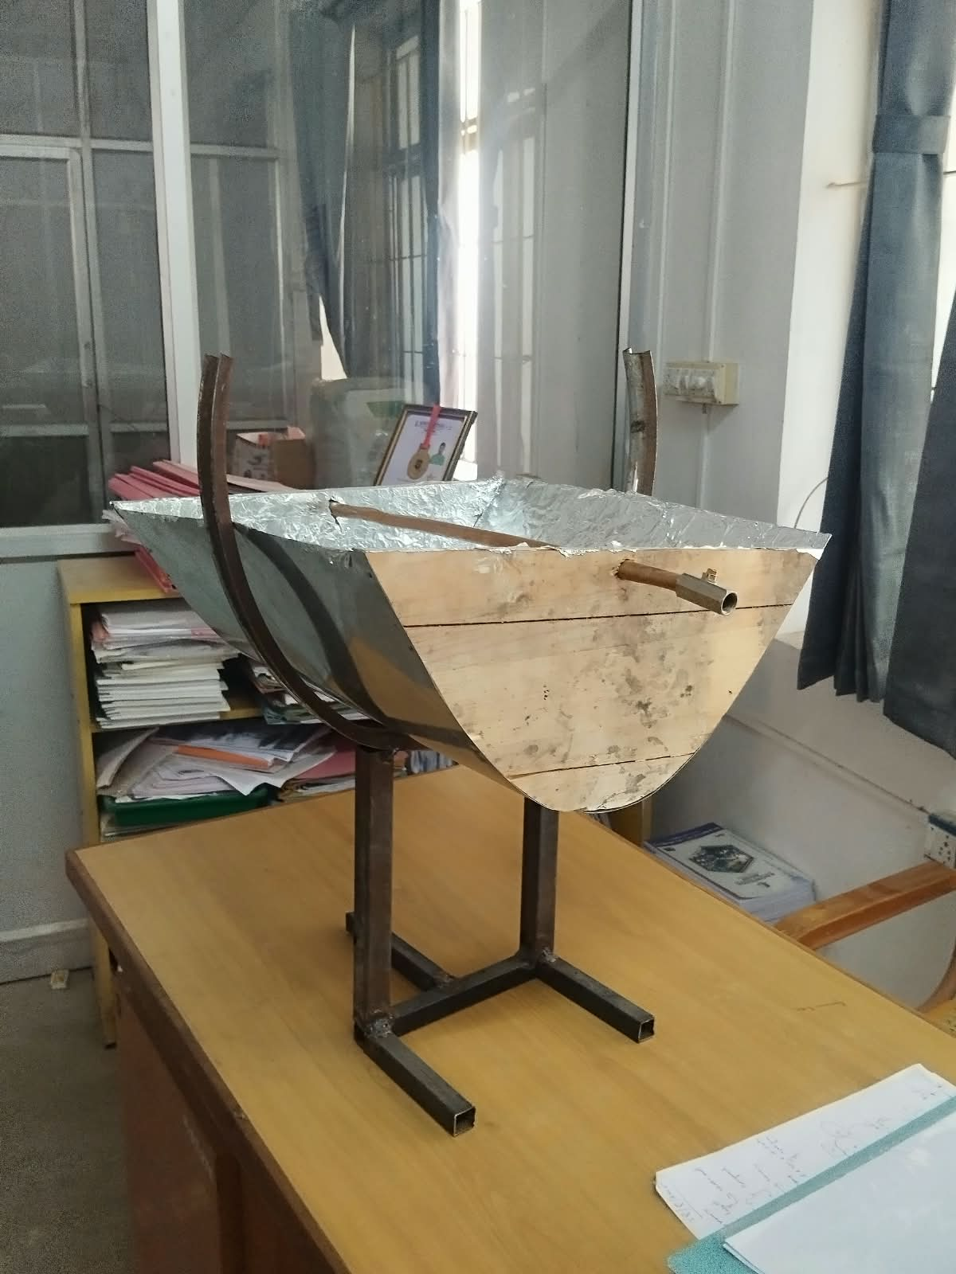
Parameters That Can Be Recorded Include Test Date, Test Time, Weather Condition, Inlet Water Temperature, Outlet Water Temperature, Temperature Rise, Water Quantity/Flow Rate, Duration of Exposure and Solar Irradiance If Available.

Figure 8.1 Experimental Setup

8.2 INLET AND OUTLET TEMPERATURE TEST
Record Inlet and Outlet Water Temperatures at Regular Intervals. Calculate ΔT = Tout − Tin for Every Observation.
Time | Inlet Temp. (°C) | Outlet Temp. (°C) | Temperature Rise (°C)
10:00 AM | 28 | 32 | 4
10:15 AM | 28 | 34 | 6
10:30 AM | 29 | 36 | 7
10:45 AM | 29 | 38 | 9
11:00 AM | 30 | 41 | 11
11:15 AM | 30 | 43 | 13
11:30 AM | 31 | 46 | 15

Table 8.1 Experimental Temperature Readings

8.3 TEMPERATURE RISE TEST
The Temperature Rise Indicates How Effectively Concentrated Solar Energy Is Transferred To The Water. For Example, If Tin = 30°C And Tout = 45°C, Then ΔT = 15°C. This Is Only An Example; Actual Project Values Must Be Used In The Final Report.
Trial | Exposure Time (Min) | Tin (°C) | Tout (°C) | ΔT (°C)
1 | 15 | 28 | 34 | 6
2 | 30 | 28 | 39 | 11
3 | 45 | 29 | 45 | 16
4 | 60 | 29 | 51 | 22
Table 8.2 Water Temperature Rise
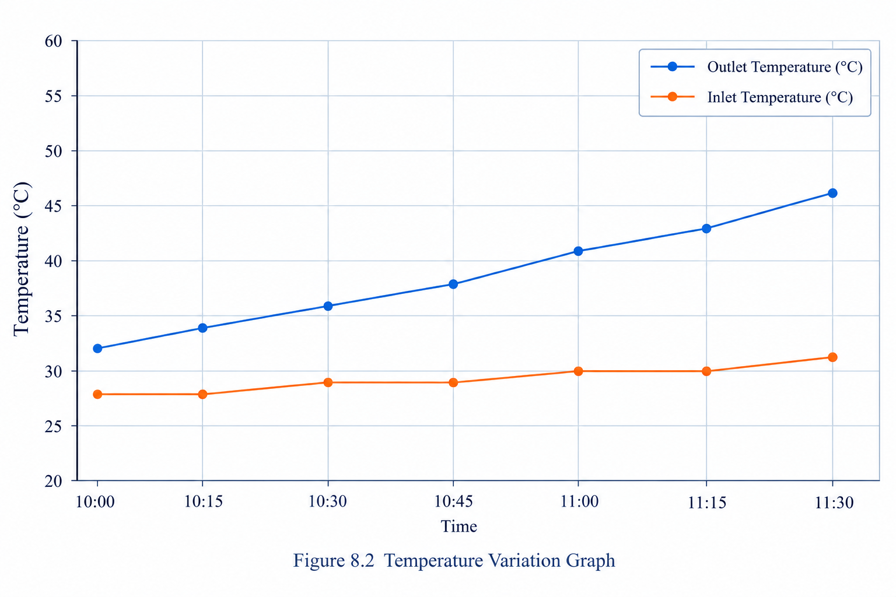
Figure 8.2 Temperature Variation Graph

8.4 SOLAR RADIATION / WEATHER OBSERVATION
Solar Heating Performance Is Affected by Time of Day, Cloud Cover, Solar Radiation Intensity, Reflector Orientation, Reflective Surface Condition, Focal-Point Accuracy, Wind, Water Flow Rate and Ambient Temperature. Strong Direct Solar Radiation and Correct Alignment Are Expected to Provide Stronger Heating.
Date | Time | Weather | Ambient Temp. (°C) | Remarks
20-03-2026 | 10AM | Sunny | 29 | Clear sky, good sunlight
21-03-2026 | 12PM | Sunny | 32 | Direct sunlight, good sunlight
Table 8.3 Weather Observation Log

8.5 WATER FLOW TEST
Different Water Flow Rates Can Be Investigated. A Lower Flow Rate Generally Provides More Time For Heat Transfer, While A Higher Flow Rate Can Increase The Quantity Of Heated Water But May Reduce The Temperature Rise Per Unit Mass.

8.6 THERMAL PERFORMANCE
Useful Heat Gain Is Q = M Cp ΔT. For Continuous Flow, Qdot = Mdot Cp ΔT. Thermal Efficiency Can Be Estimated Using Η = Qdot/(IA) When Reliable Solar Irradiance And Aperture Area Data Are Available.
Trial | Q (Kj) | Qdot (W) | I (W/M²) | Η (%)
1 | 75.35 | 83.72 | 700 | 17.09
2 | 96.28 | 106.98 | 750 | 19.11
3 | 113.02 | 125.58 | 800 | 52.33
Table 8.4 Thermal Performance
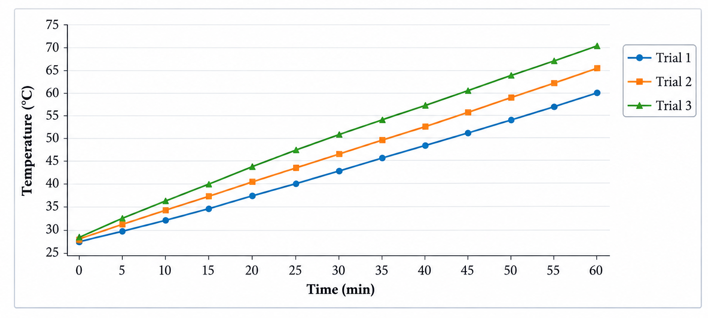
Figure 8.3 Temperature Rise Versus Time

8.7 OVERALL PERFORMANCE
The Prototype Should Be Evaluated Based On Its Ability To Concentrate Sunlight, Stability Of Focal Positioning, Copper Pipe Heating, Water Temperature Increase, Water Flow Behavior, Reflective Surface Condition, Structural Stability, Leakage Performance And Repeatability. A Successful Prototype Should Demonstrate A Measurable Increase In Outlet-Water Temperature Compared With Inlet-Water Temperature Under Suitable Solar Conditions.
Trial | Repeat Run | ΔT Achieved (°C) | Remarks
1 | Morning | 8 | Moderate heating observed
2 | Midday | 15 | Maximum heating observed
3 | Afternoon | 12 | Good heating maintained
4 | Repeat (Morning) | 9 | Similar morning performance
5 | Repeat (Midday) | 15 | Consistent midday performance
Table 8.5 Repeated Trial Results
Consistency Across Repeated Trials At Similar Times Of Day Provides Confidence That The Observed Temperature Rise Is Attributable To The Parabolic Concentration Mechanism Rather Than To Incidental Variation In Ambient Conditions. Any Significant Scatter Between Repeat Trials At Nominally Similar Solar Conditions Should Be Investigated, As It May Indicate Misalignment Of The Reflector, A Shift In Pipe Position Away From The Focal Line, Or Wrinkling/Degradation Of The Reflective Sheet.

8.8 COMPARISON WITH A CONVENTIONAL FLAT-PLATE COLLECTOR
Although A Side-By-Side Experimental Comparison with a Flat-Plate Collector Was Outside the Scope of the Present Prototype, It Is Useful to Discuss the Expected Qualitative Differences Based on the Collector Theory Reviewed in Chapter 2. A Flat-Plate Collector Absorbs Solar Radiation Over Its Full Glazed Surface Area Without Concentration, and Consequently Reaches a Comparatively Modest, Fairly Uniform Absorber Temperature. The Parabolic Trough Collector Developed In This Project, In Contrast, Concentrates the Same Incident Radiation from a Wide Aperture onto a Narrow Receiver Pipe, Which Can Achieve a Higher Local Receiver Temperature for a Given Incident Irradiance, At the Cost of Requiring More Accurate Alignment toward the Sun.
Table 8.6 Summarizes the Qualitative Trade-Offs Between the Two Approaches, Which Should Be Kept in Mind When Interpreting the Results of Sections 8.1 To 8.7.
Aspect | Flat-Plate Collector | Parabolic Trough (This Project)
Alignment Sensitivity | Low – Tolerant Of Misalignment | Higher – Requires Reasonably Accurate Orientation
Achievable Receiver Temperature | Moderate | Potentially Higher, For A Given Aperture
Construction Complexity | Glazing, Insulation, Absorber Plate | Curved Reflector, Focal Positioning
Suitability For Demonstration | Good | Good, With Added Optics/Geometry Teaching Value
Table 8.6 Qualitative Comparison with a Flat-Plate Collector

CHAPTER 9
SAFETY AND MAINTENANCE

9.1 SAFETY FEATURES
- Do not look directly at the concentrated focal region.
- Keep combustible materials away from the focal region.
- Avoid touching the copper pipe immediately after operation.
- Use heat-resistant gloves when handling hot components.
- Ensure the reflector is structurally stable.
- Ensure the copper pipe is properly supported.
- Check all water connections for leakage.
- Prevent accidental contact with concentrated sunlight.
- Do not leave the reflector unattended when strongly concentrating sunlight.
- Keep children and unauthorized persons away from the operating area.

9.2 MAINTENANCE PROCEDURE
- Clean the reflective surface periodically to remove dust and dirt.
- Inspect the wooden frame and metal sheet for deformation or damage.
- Check the copper pipe for leakage, corrosion, blockage and mechanical damage.
- Check inlet and outlet connections periodically.
- Repair wrinkles, scratches and damage on the reflective sheet because they can reduce concentration performance.

9.3 ADVANTAGES
- Uses renewable solar energy.
- Does not require electrical heating.
- No sensors required.
- No electronic controller required.
- Simple mechanical construction.
- Low operating energy requirement.
- Reduces dependence on conventional energy sources.
- Uses parabolic concentration for improved solar heating.
- Copper pipe provides an effective heat-transfer path.
- Suitable for prototype fabrication.
- Easy to understand and demonstrate.
- Can be fabricated using locally available materials.
- Useful for educational and experimental applications.

9.4 LIMITATIONS
- It depends on direct sunlight.
- Performance decreases during cloudy weather.
- Heating performance changes with time of day.
- Correct reflector alignment is important.
- The focal region can reach a high temperature.
- Reflective surface damage can reduce performance.
- Wooden components require protection from outdoor weather.
- The prototype may have limited water-heating capacity.
- Without automatic tracking, the reflector may require manual alignment.
- Thermal losses occur through convection and radiation from the receiver.

9.5 APPLICATIONS
- Domestic water preheating.
- Rural hot-water applications.
- Small-scale bathing water heating.
- Outdoor washing facilities.
- Educational laboratories.
- Solar thermal demonstrations.
- Renewable-energy projects.
- Small-scale agricultural applications.
- Experimental heat-transfer studies.
- Solar-energy research prototypes.

9.6 ENVIRONMENTAL AND ECONOMIC CONSIDERATIONS
Because the proposed system relies entirely on incident solar radiation and does not consume grid electricity or fossil fuel during operation, its use in place of an equivalent-capacity electric or LPG-based water heater can reduce the associated carbon emissions and operating cost over the useful life of the unit. The primary environmental footprint of the system arises from the materials and energy embodied in its fabrication principally the wood, sheet metal, reflective film and copper pipe rather than from its day-to-day operation.
From an economic perspective, the low material and fabrication cost estimated in Chapter 7, combined with the absence of ongoing fuel or electricity costs, suggests a comparatively short payback period relative to continued reliance on electrical water heating, particularly in regions with abundant sunshine. A more rigorous economic assessment would require site-specific data on local energy tariffs, average daily solar irradiance and the household's hot-water demand pattern, which are beyond the scope of the present prototype-level study

.

CHAPTER 10
APPENDICES
APPENDIX – 1

APPENDIX – 1: PARABOLIC PROFILE
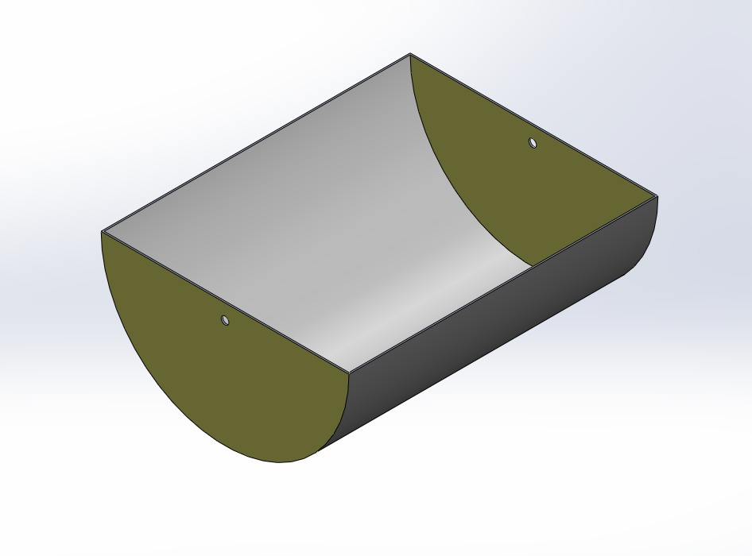
Include the exact drawing showing vertex, axis, focus, focal distance, parabolic curve, reflector width and reflector depth. Current design: focal distance = 73 mm.
Figure 10.1 Parabolic Profile Drawing
APPENDIX – 2: COMPONENTS SPECIFICATION
1. Reflective Sheet
Material: Aluminium foil reflective sheet
Properties: High reflectivity, lightweight, heat resistant
Application: Reflecting and concentrating solar radiation toward the heating chamber

2. Solar Collector / Heating Chamber
Type: Parabolic/concentrated solar heating arrangement
Material: Sheet metal with reflective inner surface
Function: Concentrates solar energy and transfers heat to the copper pipe
3. Copper Pipe
Material: Copper
Properties: High thermal conductivity, corrosion resistant
Function: Carries water through the heated region for solar water heating
4. Wooden Frame
Material: Wooden structural members
Properties: Lightweight, easy to fabricate and assemble
Application: Supporting the solar collector/heating assembly
5. Metal Support Frame
Material: Mild steel structural sections
Properties: Strong, rigid and stable
Application: Supporting the complete prototype
6. Pipe Support
Material: Metal support arrangement
Function: Holds the copper pipe securely in position
Application: Maintaining proper alignment of the pipe inside the heating chamber
7. Water Inlet Pipe
Material: Copper/metal pipe
Function: Provides water entry into the heating system
Application: Allows water to flow through the heated section
8. Water Outlet Pipe
Material: Copper/metal pipe
Function: Provides heated-water outlet
Application: Delivering heated water from the system
9. Fasteners / Joints
Type: Mechanical fastening arrangement
Function: Joining and securing the frame and component assemblies
Application: Providing structural stability to the prototype
10. Adjustable Support
Material: Metal support members
Function: Supporting and positioning the collector assembly
Application: Maintaining the required orientation toward sunlight
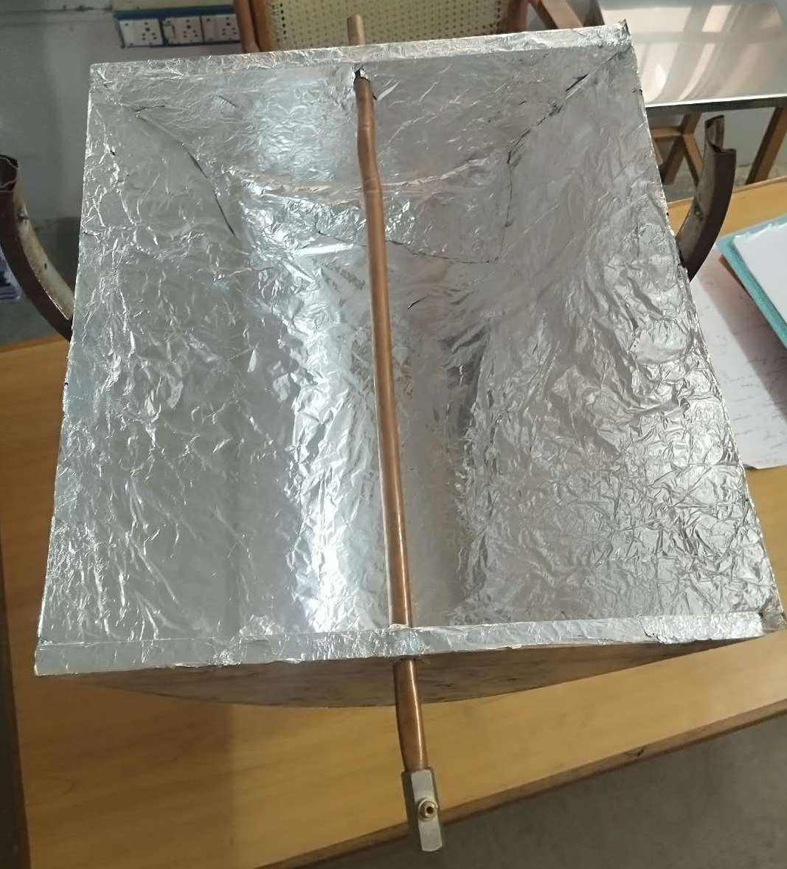
APPENDIX – 3: PROTOTYPE PHOTOGRAPHS

TOP VIEW
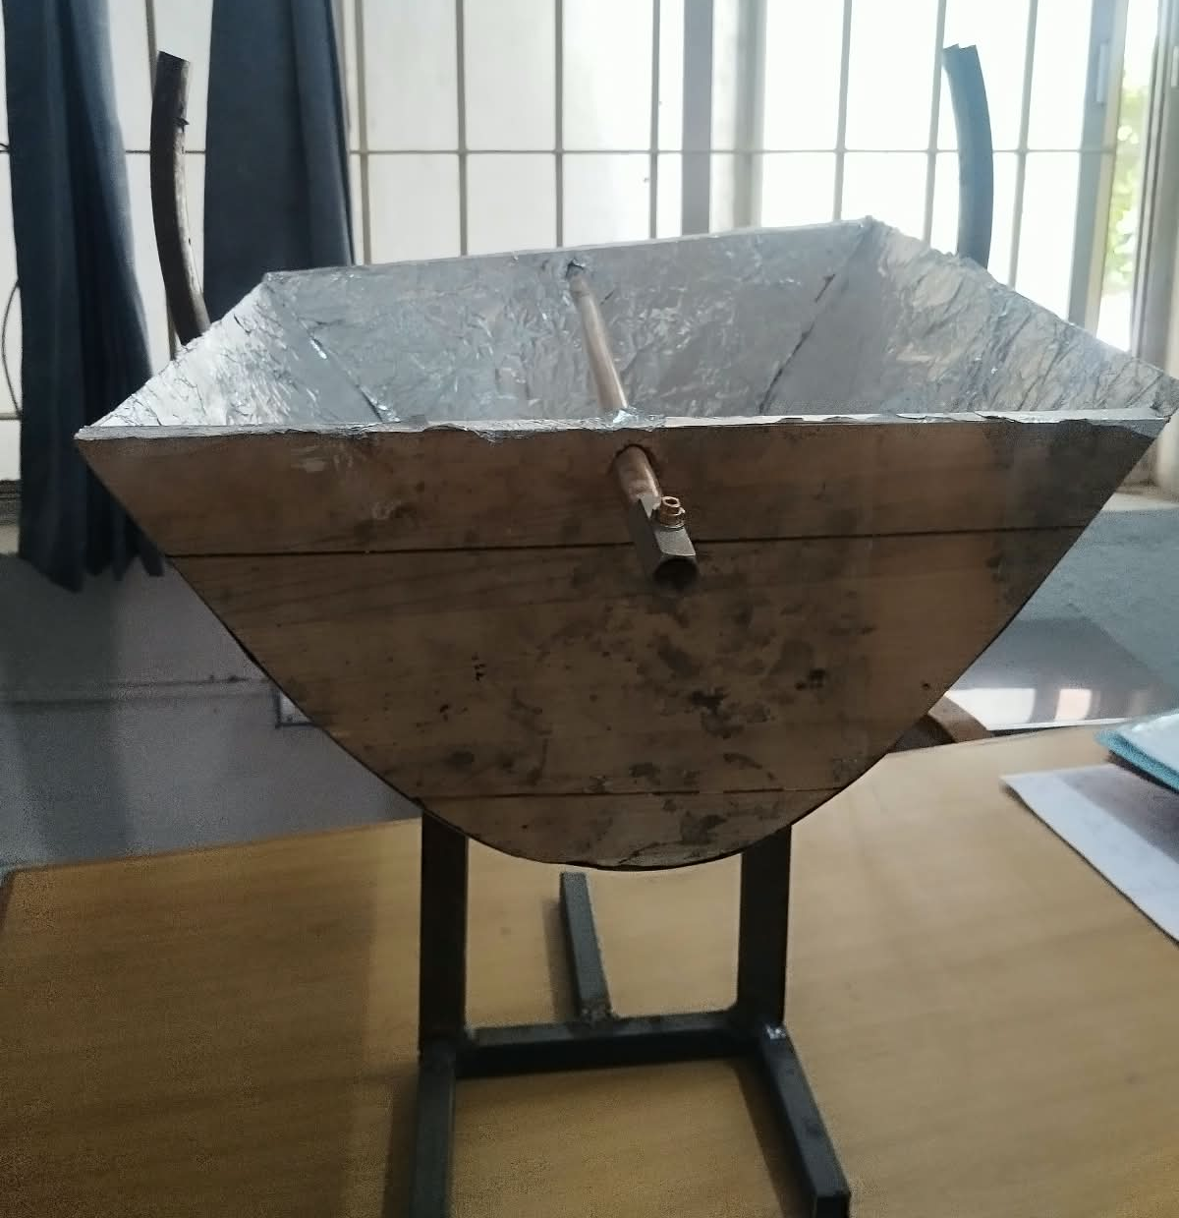
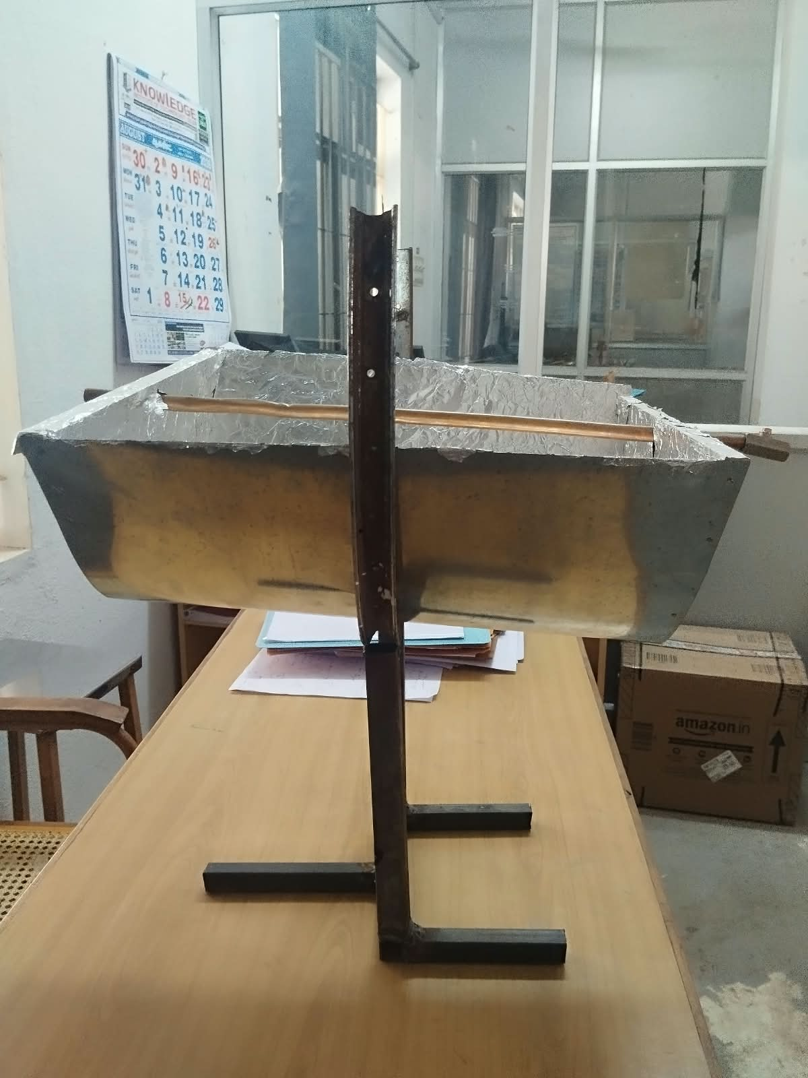
FRONT VIEW

SIDE VIEW
ISOMETRIC VIEW

CHAPTER 11
CONCLUSION
The project successfully proposes the design and fabrication of a mechanically operated parabolic solar water heater using a copper pipe as the solar receiver. The system utilizes the concentrating property of a parabolic reflector to collect and redirect solar radiation toward the focal region. The proposed reflector is fabricated using a wooden supporting structure, curved metal sheet and reflective sheet. Based on the developed parabolic geometry, the focal point is positioned approximately 73 mm from the vertex, and the copper pipe is located in this focal region to receive the concentrated solar radiation. When sunlight falls on the reflector, the reflective surface redirects the radiation toward the copper pipe. The concentrated solar energy increases the temperature of the copper pipe, and heat is subsequently transferred to the water flowing through it. Thus, the system demonstrates the conversion of solar radiation into useful thermal energy for water heating. The major advantage of the proposed system is its simple mechanical construction and absence of electrical or electronic components. The system does not require sensors, microcontrollers, IoT connectivity or an electrical heating element. This reduces system complexity and makes the prototype suitable for educational, experimental and small-scale solar thermal applications. The performance of the system can be evaluated through inlet and outlet water-temperature measurements under different solar conditions. The temperature rise, useful heat gain and thermal efficiency can be determined from the experimental data, as illustrated by the worked example and the trial tables presented in Chapters 5 and 8 of this report. Overall, the project demonstrates that parabolic solar concentration combined with a copper pipe receiver can be used as a simple mechanical approach for solar water heating. Further improvements can focus on better reflective materials, improved insulation, more accurate focal positioning, larger collector area, improved pipe geometry, a selective absorber coating on the receiver pipe, and manual or mechanical sun-tracking mechanisms to further enhance the useful heat gain achievable from a given aperture area.

REFERENCES
[1] S. A. Kalogirou, “Solar thermal collectors and applications,” Progress in Energy and Combustion Science, Vol. 30, No. 3, pp. 231–295, 2004. DOI: 10.1016/j.pecs.2004.02.001.
Direct Link: https://www.sciencedirect.com/science/article/abs/pii/S0360128504000103
[2] J. A. Duffie, W. A. Beckman and N. Blair, “Solar Water Heating,” in Solar Engineering of Thermal Processes, Photovoltaics and Wind, Wiley, 2020.
Direct Link: https://onlinelibrary.wiley.com/doi/abs/10.1002/9781119540328.ch12
[3] “A review on solar water heating technology: Impacts of parameters and techno-economic studies,” Bulletin of the National Research Centre, 2024. Direct Link: https://link.springer.com/article/10.1186/s42269-024-01187-1
[4] A. J. Abdulhamed, N. M. Adam, M. Z. A. Ab-Kadir and A. A. Hairuddin, “Review of solar parabolic-trough collector geometrical and thermal analyses, performance, and applications,” Renewable and Sustainable Energy Reviews, Vol. 91, pp. 822–831, 2018. DOI: 10.1016/j.rser.2018.04.085.Direct Link: https://doi.org/10.1016/j.rser.2018.04.085
[5] A. Malan and K. Ravi Kumar, “A comprehensive review on optical analysis of parabolic trough solar collector,” Sustainable Energy Technologies and Assessments, Vol. 46, Article 101305, 2021. DOI: 10.1016/j.seta.2021.101305.
Direct Link: https://www.sciencedirect.com/science/article/pii/S2213138821003155
[6] A. Malan and K. Ravi Kumar, “Performance Benchmarking of Large Aperture Parabolic Trough Solar Collector for Various Optical Errors and Geometrical Concentration Ratio,” Energy Technology, 2022. DOI: 10.1002/ente.202100533.
Direct Link: https://doi.org/10.1002/ente.202100533
[7] L. Salgado Conrado, A. Rodriguez-Pulido and G. Calderón, “Thermal performance of parabolic trough solar collectors,” Renewable and Sustainable Energy Reviews, Vol. 67, pp. 1345–1359, 2017. DOI: 10.1016/j.rser.2016.09.071.
Direct Link: https://www.sciencedirect.com/science/article/abs/pii/S1364032116305615
[8] G. K. Manikandan, S. Iniyan and R. Goic, “Enhancing the optical and thermal efficiency of a parabolic trough collector – A review,” Applied Energy, Vol. 235, pp. 1524–1540, 2019. DOI: 10.1016/j.apenergy.2018.11.048.
Direct Link: https://www.sciencedirect.com/science/article/pii/S0306261918317537
[9] G. Kumaresan, P. Sudhakar, R. Santosh and R. Velraj, “Experimental and numerical studies of thermal performance enhancement in the receiver part of solar parabolic trough collectors,” Renewable and Sustainable Energy Reviews, Vol. 77, pp. 1363–1374, 2017. DOI: 10.1016/j.rser.2017.01.171.
Direct Link: https://doi.org/10.1016/j.rser.2017.01.171
[10] D. Lei, Q. Li, Z. Wang, J. Li and J. Li, “An experimental study of thermal characterization of parabolic trough receivers,” Energy Conversion and Management, Vol. 69, pp. 107–115, 2013. DOI: 10.1016/j.enconman.2013.02.002.
Direct Link: https://doi.org/10.1016/j.enconman.2013.02.002
[11] B. Zou, J. Dong, Y. Yao and Y. Jiang, “An experimental investigation on a small-sized parabolic trough solar collector for water heating in cold areas,” Applied Energy, Vol. 163, pp. 396–407, 2016. DOI: 10.1016/j.apenergy.2015.10.186.
Direct Link: https://www.sciencedirect.com/science/article/abs/pii/S0306261915014361
[12] A. Özcan, A. G. Devecioğlu and V. Oruç, “Experimental and numerical analysis of a parabolic trough solar collector for water heating application,” Energy Sources, Part A: Recovery, Utilization, and Environmental Effects, 2022. DOI: 10.1080/15567036.2021.1924317.
Direct Link: https://doi.org/10.1080/15567036.2021.1924317
[13] “Experimental Investigations on Mild Steel Compound Parabolic Reflector with Aluminum Foil as Selective Surface and Top Cover,” Energy Procedia, Vol. 57, pp. 3058–3070, 2014/2015. DOI: 10.1016/j.egypro.2015.06.052.
Direct Link: https://www.sciencedirect.com/science/article/pii/S1876610215007420
[14] A. A. Sagade, A. Mawire, B. Belgasim, M. A. Tawfik and N. A. Sagade, “Experimental performance evaluation of a parabolic dish solar geyser using a generalized approach for decentralized applications,” Sustainable Energy Technologies and Assessments, Vol. 47, Article 101454, 2021. DOI: 10.1016/j.seta.2021.101454.
Direct Link: https://www.sciencedirect.com/science/article/pii/S2213138821004641
[15] U. C. Arunachala, “Experimental study with analytical validation of energy parameters in parabolic trough collector with twisted tape insert,” Journal of Solar Energy Engineering, Vol. 142, No. 3, 2020. DOI: 10.1115/1.4045825.
Direct Link: https://doi.org/10.1115/1.4045825
[16] A. Munusamy, D. Barik, S. S. R. Chandran, K. E. Reby Roy, P. Paramasivam and S. S. Murthy, “Experimental analysis of the effect of copper dimple tube with aluminum coating on the performance of parabolic solar water heater using helically twisted tape,” Advances in Mechanical Engineering, 2024. DOI: 10.1177/16878132241262679.
Direct Link: https://journals.sagepub.com/doi/10.1177/16878132241262679
[17] “Experimental Study of a Stationary Parabolic Trough Collector with Modified Absorbers for Domestic Water Heating,” Energies, Vol. 18, 2025.
Direct Link: https://www.mdpi.com/1996-1073/18/13/3261
[18] N. Abed and I. Afgan, “An extensive review of various technologies for enhancing the thermal and optical performances of parabolic trough collectors,” International Journal of Energy Research, Vol. 44, No. 7, pp. 5117–5164, 2020. DOI: 10.1002/er.5271.
Direct Link: https://onlinelibrary.wiley.com/doi/10.1002/er.5271
[19] M. Sharma and R. Jilte, “A review on passive methods for thermal performance enhancement in parabolic trough solar collectors,” International Journal of Energy Research, Vol. 45, pp. 4932–4966, 2021. DOI: 10.1002/er.6212.
Direct Link: https://onlinelibrary.wiley.com/doi/10.1002/er.6212
[20] K. S. Reddy, K. R. Kumar and G. V. Satyanarayana, “Numerical investigation of energy-efficient receiver for solar parabolic trough concentrator,” Heat Transfer Engineering, Vol. 29, No. 11, pp. 961–972, 2008. DOI: 10.1080/01457630802125757.
Direct Link: https://doi.org/10.1080/01457630802125757

